## **Intro**

This exercise is comprised of 2 steps.

To complete it, you are provided with some resource files:

Resources:

https://drive.google.com/drive/folders/1xsvEkb9Alm8Oag64HKEMSDGPoiEwo5ll

Please go over the resources before continuing reading

Please go over All the steps before you begin implementing

General Notes:

* All 3rd party API Calls are via their respective official Rest API
* All Config\Files files should be stored in JSON format

You will be tested on:

* Code cleanliness & readability
* Correct layers design & design patterns
* Error handling
* The ability to understand what is asked from you
* Production code best practices (ie: logging, input validations, etc.)

Good luck!

## **Step 1 - Create a Connector**

A Connector is a script with some input parameters, that is being run periodically and scheduled by some management framework.

The connectors goal is to connect to some 3rd party product, fetch and process data from it using its API, and deliver that data back to the framework (in the data format that the framework expects).

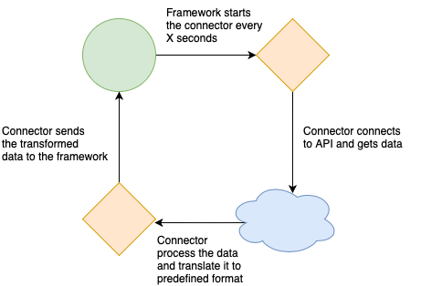

In this exercise, the communication with the framework will done via the SubProcessInputOutputHandler class.

A Stub is available for you in the [Resources folder](https://drive.google.com/drive/folders/1xsvEkb9Alm8Oag64HKEMSDGPoiEwo5ll?usp=sharing).

* Use SubProcessInputOutputHandler.connector_params at the start of the script to get the connector inputed parameters.
* Use SubProcessInputOutputHandler.end at the end of the script to return the output to the framework.

The framework runs the connector periodically every X seconds (ie: every 10 seconds).

In each iteration, the connector’s main method is called.

You case use the ***VirusTotalConnector.py*** stub from the Resources folder

### **Connector - Virus Total**

The objective of this connector is, in each iteration, read a list of entities (domains) from a file, and for each entity scan it using the[**VirusTotal**](https://developers.virustotal.com/v3.0/reference#overview)API, and return data about suspicious entities, as part of the ConnectorResult output.

* Source Files:
  + All sources files are stored in a single folder, its path is given as a parameter to the connector
  + In each iteration, the connector should process a single file from the source folder
  + Each file will contain a list of entities (domains - ie: [msn.com](http://msn.com))
  + Choose any format you want for the files (ie: json, CSV, free text)
  + At the end of each iteration, add “.done” suffix to the file name to mark it as done
  + From each file, read only a limited number of entities, the limit should be provided via a paremeter
* For each hostname, query the VirusTotal API and return result as part of the ConnectorResult
  + Result format is a dictionary of string:any, when the key is the entity (hostname) and the value is:
    - if an entity is suspicious (define suspiciousness based on “reputation” field) : return it with relevant data (of your choosing)
    - If an entity is not suspicious: return it with “Not Suspicious”
* For this step, you can implement the SubProcessInputOutputHandler to input\output from hardcoded files, and just run the *VirusTotalConncetor.py* manually **OR** implement step 1 + 2 together.

## **Step 2 - Write a Connector Service Framework**

### **Cycle Service:**

The Cycle service is a service with an infinite loop, that runs python subprocess of connector scripts at configured intervals. The connectors generate data, and the Cycle service saves it to an output folder.

The framework is designed to accommodate different types of connector (each with its own code), and run several instances of them with separate configuration.

For this part, we will test the Cycle service with 2 instances of the same type of connector we implemented in step 1, each with it’s own source folder, and output_folder.

* Connector settings config file:
  + This file location can be hardcoded, it can contain the settings of all the connectors
  + Each connector has it’s own parameters configurations
  + Interval is defined for each connector
    - Interval determines how much time should pass between the moment the connector has finished, until the moment it will start again.
* *Connector (Sub Process) Input/Output:*
  + **Input**: Pass the parameters of the connector from the settings, to the sub-process via the **stdin channel** (not as process args) (you can come up with any protocol you want for this)
  + **Output**: Pass the connector output from the sub-process to the service as an AlertsPackage object via the **stdout channel**
* Service Output Folder:
  + After each iteration, save the connector output to a new timestamped file
  + This folder path can be hardcoded

For this exercise, the “service” can be a manually executed python program.

It’s important to implement the loop yourself (and not use a Scheduler for example)

**Notice** - the Cycle service shouldn’t fail if the connector script has failed. However it should report if the connector completed successfully or not.

### **SubProcessInputOutputHandler:**

A class that wraps the input\output communication with the host-process.

A stub is available in the resources folder. Please adjust it to run as part of the Cycle service.

The class should expose the following:

* ***Property*** *connector_params -* parsed out parameters fromcurrent process stdin input
* ***end(alerts_package)*** method
  + Will receive an ConnectorResult object, will return it via the stdout
  + Will end the current process